Game Design Document

Fill up the following document

1. Write the title of your project.

Collect the fish

1. What is the goal of the game?

Collect as many fish as you can in 45 seconds without getting eaten by shark

1. Write a brief story of your game.

1. Which are the playing characters of this game?

* Playing characters are the ones who respond to the user based on the input from the user.
* Cars, monkeys, dinos, wizards, etc., are the playing characters in the game.

|  |  |  |
| --- | --- | --- |
| Number | Character Name | What can this character do? |
| 1 | Dory | Hunts for other fish |
| 2 | shark | Try to attack dory |
| 3 |  |  |
| 4 |  |  |
| 5 |  |  |
| 6 |  |  |
| 7 |  |  |
| 8 |  |  |

1. Which are the Non-Playing Characters of this game?

* Non-Playing characters are the ones that don't have an action or behavior when the user interacts with the game.
* Hurdles, stones, bananas, coins, etc., are non-playing characters in the game.

|  |  |  |
| --- | --- | --- |
| Number | Character Name | What can this character do? |
| 1 | Other fish | Disappier when touched by dory |
| 2 |  |  |
| 3 |  |  |
| 4 |  |  |
| 5 |  |  |
| 6 |  |  |
| 7 |  |  |
| 8 |  |  |

Draw your imagination of this game. What does this game look like?

* Draw the game either on your computer or on paper.
* Add images of the game scenes to show each of the playing and non-playing characters at least once.

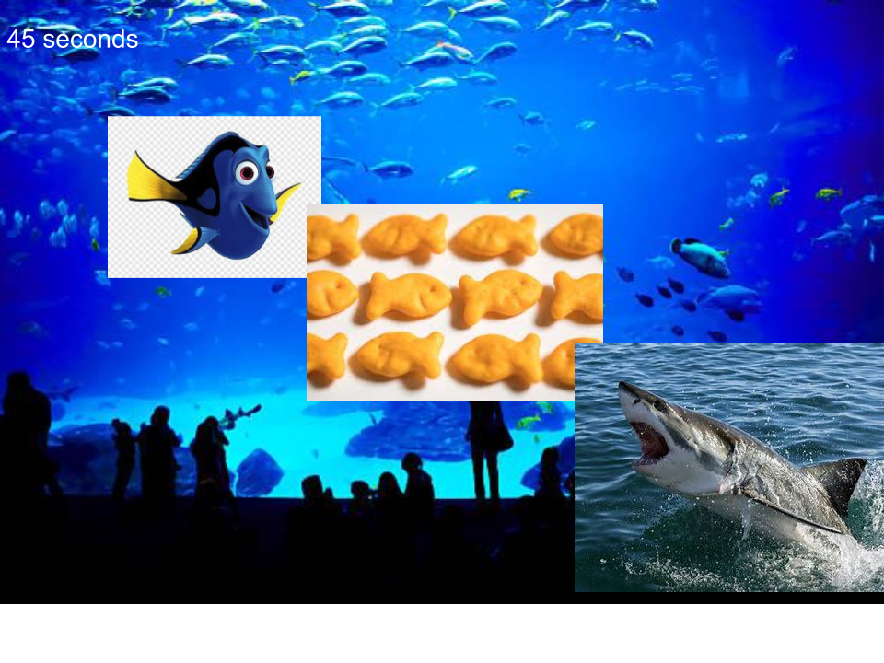

How do you plan to make your game engaging?

My game will be a race and hopefully people will be engaged because they wanna win.